**Assignment Day 3,(2nd December 2020)**

**Question and Answer**

1. Create a blank file named "myfile"

Ans:

--->”touch” command is used to create empty file(blank file)

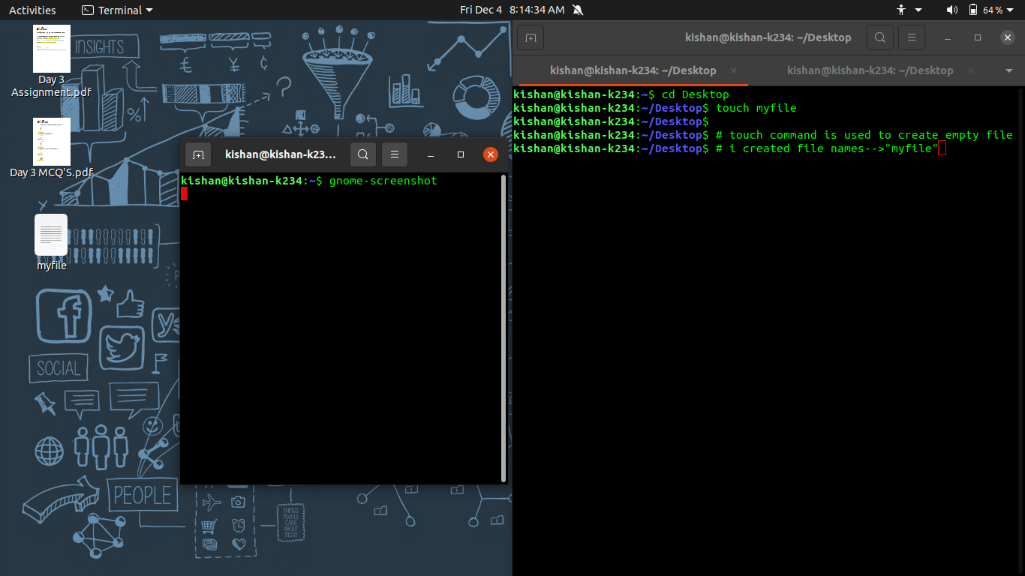

Fig: Creating blank file

1. Open “myfile” in vi editor

Ans 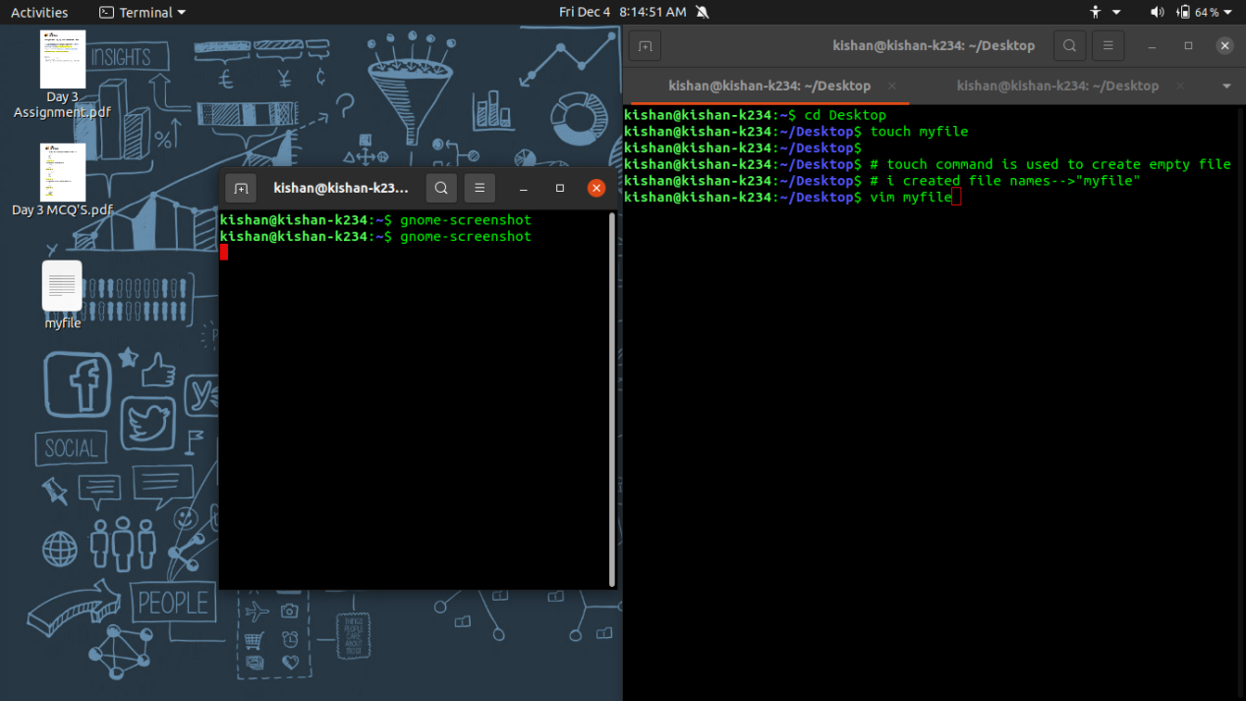

Fig: Opening file in VIM editor

1. Write your name, address, email id, phone number and blood group in 5 different lines

Ans

--> “i” is to insert into writing commands in the editor

--> “x” is to save the file

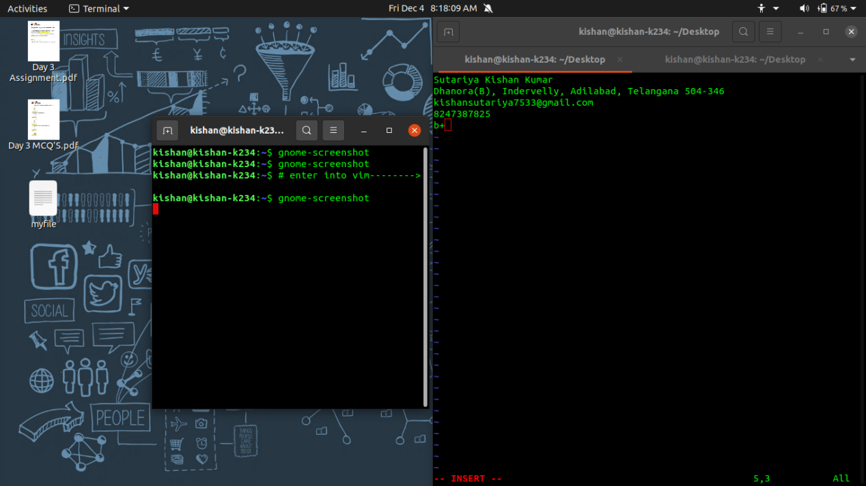

Fig: Writing in VIM editor

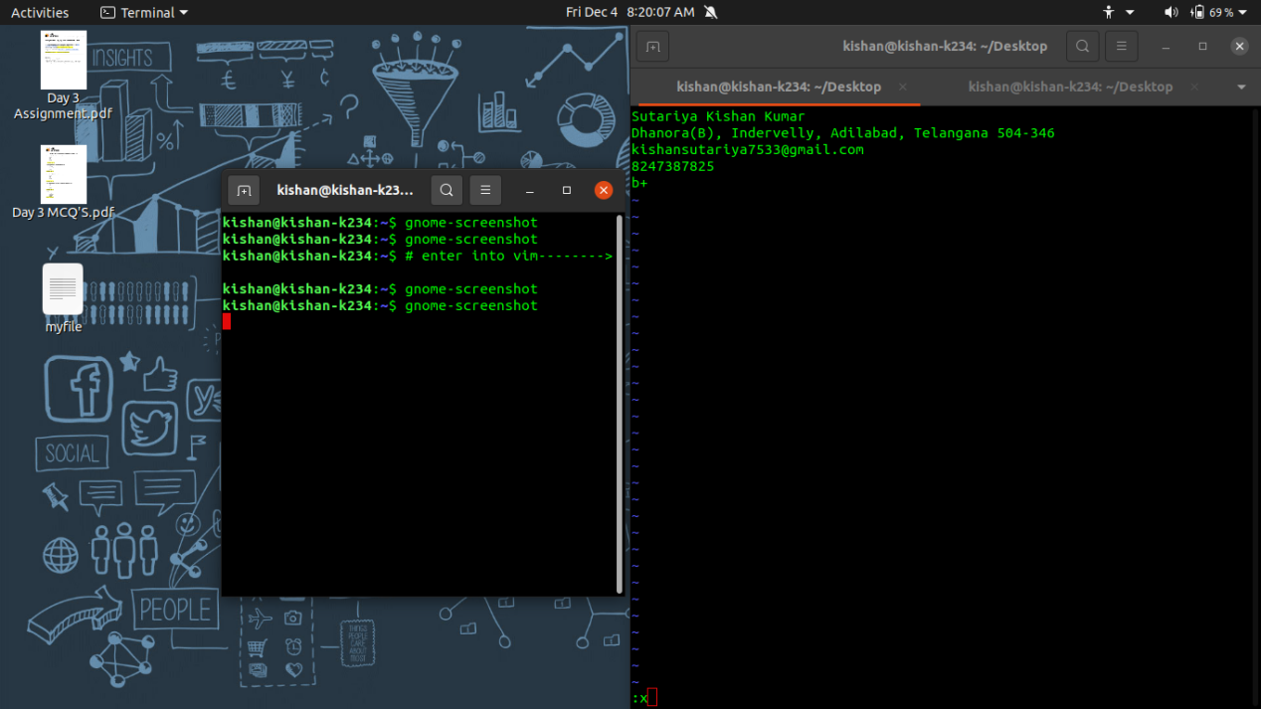

Fig: saving file

4) Build one single expression to see the line with your name and blood group in myfile

Ans

---> “head myfile” command is used to get starting 10 lines of given file

--> “head -2 myfile” is command used to get only first 2 lines of file named myfile

--->(head -n && tail -n) >myfile is command to print first and last line of give filename

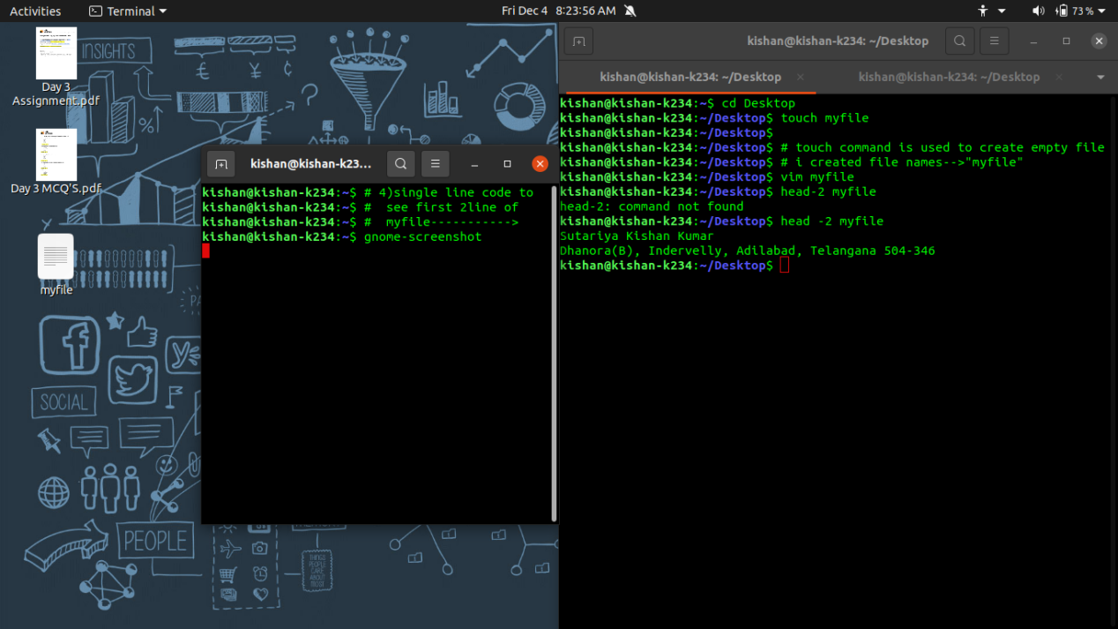

Fig: Expression to see first 2 lines

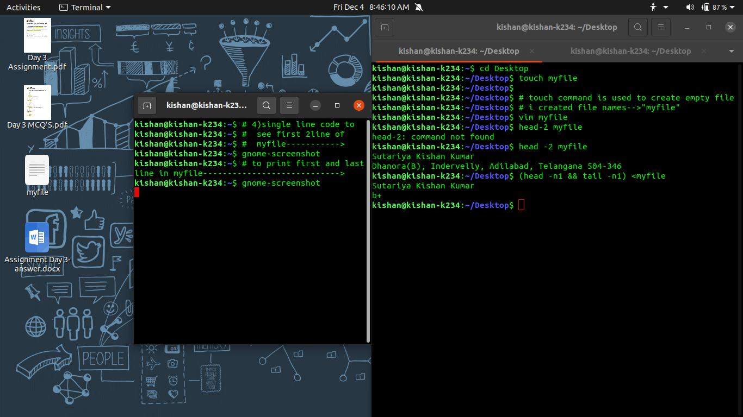

Fig: Expression to see name and blood-group